Doing your best on the CCCE exam

Contents
Best Practices 3
Where is the best place to study? 3
When is the best time to study? 3
How Long to study? 3
Have all your materials on hand when studying 4
Study Smarter Not Harder 4
Understand the CCCE suite of assessment 5
Know the exam breakdown 5
Know the types of exam questions 5
Definition matching 6
Memory 6
Memory-Plus 6
Cause-and-effect 7
Justify method 7
Know how to answer multiple-choice questions 7
General multiple-choice guidance 7
Getting familiar with CCCE exam 8
Know the study breakdown 8
Know what month 1 studying entails 9
Week 1: read entire Commercial Cannabis Handbook 9
Week 2: About ACCCE & Breakdown of Commercial Cannabis Industry 9
Week 3-4: Breakdown of Commercial Cannabis Industry 10
Know what Month 2 Studying entails 10
Week 5-7: Cannabis Risk Management Framework (CRMF) 10
Know what Month 3 Studying entails 12
Week 8-10: Risk Assessment 12
Week 11-12: Re-review the Commercial Cannabis Handbook 14

While you can try to grasp large quantities of information for the exam, if you are not prepared mentally and physically, your chances of success drop drastically. Studying for an exam is no easy feat. Often just thinking about it causes stress and anxiety.
ACCCE is committed to the success of every member, so before beginning to study for the exam we have laid out how to best use your time by learning the essential objectives and knowledge covered on the test, getting familiar with the test itself, practicing smart techniques, and having a good strategy leading up to the exam.

Best Practices
Best practices are important to incorporate into your studying habits because they provide you with effective guidelines on where, when, and how long to study.

Where is the best place to study?
When studying you should have as few distractions as possible. Find a quiet area where you can focus your attention on the material at hand.

When is the best time to study?
Study early in the day if you can. Studies have shown that your mental capacity to retain information decreases the longer you have been awake.

How Long to study?
The more you spread out your study time, the more likely you are to remember information later, compared to cramming all your study time into a few sessions. It is best to learn in bite size pieces. Pace yourself and have a schedule.
Remember
Spread out your study time.
Pace yourself and have a schedule.
Each person is unique and learns and absorbs information at different rates; the time and duration of study may need to be extended or decreased based on individual learning abilities.

Have all your materials on hand when studying
The Commercial Cannabis Handbook is only available online so when you begin to study, make sure you have adequate internet connection.
Remember
You have two chances to take the exam.
Flashcards are great learning tools and will help your brain remember concepts and definitions from the handbook.
It is good to have a notebook and pen handy for any notes you may want to take.

Study smarter not harder
- All the answers in the exam can be found in the Commercial Cannabis Handbook.
- ACCCE has developed exam prep videos where we provide members access to overviews of the Breakdown of Commercial Cannabis Industry, Cannabis Risk Management Framework and Risk Assessment.
- ACCCE has created complimentary live Community Discussions where ACCCE staff will answer the section specific questions as well as review any examples you would like more clarification on. These thirty-minute discussions are geared towards providing you with a better understanding of major concepts discussed in the Commercial Cannabis Handbook. Keep your eye out for these sessions. You can find the dates of the next community discussion in the events section of our website.
- Know and understand the objectives of each section. People often skim over the objectives of a section, but they are very important because they indicate what you will be tested on.
- The first time a concept is discussed in the handbook, it is defined. They will be highlighted in blue. These are important Industry terms, concepts, and definitions that you should pay attention to as a large portion of the exam is focused on this.
- Infographics emphasize important information; these pieces of information are generally tested.

Understand The CCCE Suite of Assessment
Knowing how the CCCE exam is broken down and the types of questions that will be asked will provide you with an added advantage. You can tailor your studying needs based on the information provided below.

Know the exam breakdown
The CCCE exam consists of 80 questions and is broken down as follows:
Section | # of questions
About ACCCE | 4
Breakdown of Commercial Cannabis Industry | 17
Cannabis Risk Management Framework | 28
Risk Assessment | 31

Know the types of exam questions
This is a multiple-choice exam where you will be asked to select the correct answer(s) from choices that are offered as a list.
There are five types of questions we will ask on the exam:
- Definition matching
- Memory
- Memory-plus
- Cause-and-effect relationship
- Justify methods
Examples of each type are displayed below.
Study Hint
Most of the exam questions are focused on the last 3 sections (Breakdown of Commercial Cannabis Industry, the CRMF and Risk Assessment). This will help guide you how best to allocate your study time.

Definition matching
Match each term with the correct definition:
_ Residual Risk _ Strategic Risk _ Inherent Risk _Operational Risk
- The level of risk that the commercial cannabis business is exposed to without the implementation of controls.
- Strategic risk poses a threat to disrupt a strategy implemented by an organization.
- The risk remaining after controls have been applied to an inherent risk.
- The exposure to legal penalties, financial forfeiture, and material loss an organization faces if it chooses the wrong business decision(s).

Memory
Which of the following is NOT one of the five main ACCCE risk areas?
- Money laundering risk
- Illicit cannabis market risk
- Reputational risk
- Supply chain risk

Memory-Plus
Which one of the following is the best example of inversion within a commercial cannabis industry?
- Extractors allowing after-hours use of equipment to unlicensed individuals
- When an illegal retailer sells marijuana to the public pretending to be a legal retailer
- Growers abusing their license to produce cannabis bound for the black market
Study Hint
The majority of the exam questions are centered around memory-plus application, cause-and-effect, and justify method.

Cause-and-effect
Why is it important for commercial cannabis businesses to establish a formal written risk program?
- It is not important
- So they can sell their risk program to others and make a profit
- Formal written risk programs stop money laundering risks posed to commercial cannabis businesses
- The risk program is an essential source document that may serve as a training and reference tool for employees

Justify method
Why is the Cannabis Risk Management Framework (CRMF) necessary to commercial cannabis businesses?
- To help assess risk
- For establishing processes to achieve the commercial cannabis business’s objectives within a risk appetite
- To create an adequate risk response
- To reduce the frequency and impact of risk events

Know how to answer multiple-choice questions

General multiple-choice guidance
- Read the question carefully before choosing a response. Sometimes we throw in a word or phrase that can change the meaning of a statement.
- Be aware of words like “always,” “never,” “only,” “must,” and “completely.” These are usually the wrong answers since there are many exceptions to rules. These are extreme words that are more than likely to be the wrong choice.
- Select all that apply may only be one correct answer. All does not necessarily mean there is more than one correct answer
- If you must guess, keep in mind that sometimes lengthy or highly specific answers will be the correct answer.

Getting familiar with CCCE exam
Prioritizing and managing the time you have available to study will help you achieve your goals of passing the CCCE exam. Effective time management will keep you on track and decrease the possibility of taking on more than you can handle.

Know the study breakdown
We have estimated it will take approximately 30-60 hours over a 12-week period to study. This breaks down into 2.5-5 hours of study time per week. We have allocated 1 hour for each session exam prep video. Each video in the session mini-series is approximately 3-5 minutes in duration. Incorporate this into your study time as needed.
This is how we have broken down the 30-60 hours:
Read entire Commercial Cannabis Handbook | 2.5 - 5 hours
About ACCCE | 0.5 - 1 hour
Breakdown of Commercial Cannabis Industry | 7.5 - 15 hours
Cannabis Risk Management Framework | 8.5 - 17 hours
Risk Assessment | 8.5 - 17 hours
Re-review Commercial Cannabis Handbook | 2.5 - 5 hours
We have created sample calendars to help you organize study time for the CCCE exam. This is based on an individual who will schedule 60 hours of study time and who will spread out his/her time relatively equally across the 3 main sections on the exam.
- Month 1
Study Tool
Use the study calendar to help structure your study time in an efficient and effective way.
- Month 2
- Month 3
Pace yourself according to your individual learning abilities and modify the calendars as needed.

Know what month 1 studying entails

Week 1: Read entire Commercial Cannabis Handbook
When beginning to study for the CCCE exam, read through the Commercial Cannabis Handbook to become familiar with the material and how the sections are set up.
We suggest setting aside 5 hours to do a careful read through.
Study Tool Tip
Creating flashcards after you have reviewed each section will help you memorize key definitions and concepts.
Sample of how to break up your study time for week 1:
- About ACCCE: 45 minutes
- Breakdown of Commercial Cannabis Industry: 1 hour
- Cannabis Risk Management Framework: 1.5 hours
- Risk Assessment: 1.75 hours

Week 2: About ACCCE & Breakdown of Commercial Cannabis Industry

About ACCCE
Have the About ACCCE section objectives available as you start to study.
- Describe ACCCE’s role and importance
- State the Mission of ACCCE
Study Tool
Don’t forget to incorporate exam prep section videos into your study time.
- Differentiate between the ACCCE designations
Once you have completed the section, review the objectives and section conclusion to test your knowledge

Breakdown of Commercial Cannabis Industry (BCCI)
We suggest watching the exam prep video created for this section before starting to study. It will provide insight on where to focus your attention.
Have the Breakdown of Commercial Cannabis Industry section objectives available as you start to study.
- Understand the key components of the commercial cannabis industry
- Understand the standard vernacular for the commercial cannabis sectors
- Understand the flow of the supply chain for the commercial cannabis industry
Once you have completed the section, review the objectives and section conclusion to test your knowledge.
Study hints for Breakdown of Commercial Cannabis Industry
- The commercial cannabis industry can be broken down by sectors to identify how the cannabis product is progressing through the supply chain and the key activities that are being performed within that sector. This provides a foundation of the inherent risks that commercial cannabis businesses within these subsectors face.
- Testing occurs at many stages because there are many potential sources of contamination from growing to when it reaches the end customer.
- Finished goods does not imply they are ready for sale to a consumer but rather a state of the cannabis product. Generally, packaging must take place for a finished good to be sold to a consumer.

Week 3-4: Breakdown of Commercial Cannabis Industry
When you have finished reviewing the Breakdown of Commercial Cannabis Industry section in the handbook and have watched the exam prep video, check out the Community Discussions on the Breakdown of Commercial Cannabis Industry. During these live discussions, we will identify risk scenarios to talk through and provide opportunities for attendees to ask questions. Dates of the next Community Discussion can be found in the events section of the ACCCE website.

Know what month 2 Studying entails

Week 5-7: Cannabis Risk Management Framework (CRMF)
We suggest watching the exam prep video created for this section before starting to study. It will provide insight on where to focus your attention.
Study Tool
Once you have read a section in its entirety, start creating flashcards of major concepts and definitions.
Have the CRMF section objectives available as you start to study.
- Describe the major components of the CRMF
- Explain the roles and major responsibilities involved in the CRMF
- Apply the CRMF to specific situations in the commercial cannabis industry
- Define vernacular involved in implementing the CRMF
- Discuss the process of identifying and mitigating risk using the CRMF
Once you have completed the section, review the objectives and conclusion to test your knowledge.
When you have finished reviewing the Cannabis Risk Management Framework section in the handbook and watched the associated exam prep videos, check out our Community Discussions on the Cannabis Risk Management Framework. During these live discussions, we will identify risk scenarios to talk through and provide opportunities for attendees to ask questions. Dates of the next Community Discussion can be found in the events section of the ACCCE website.
Know: The six components of the CRMF
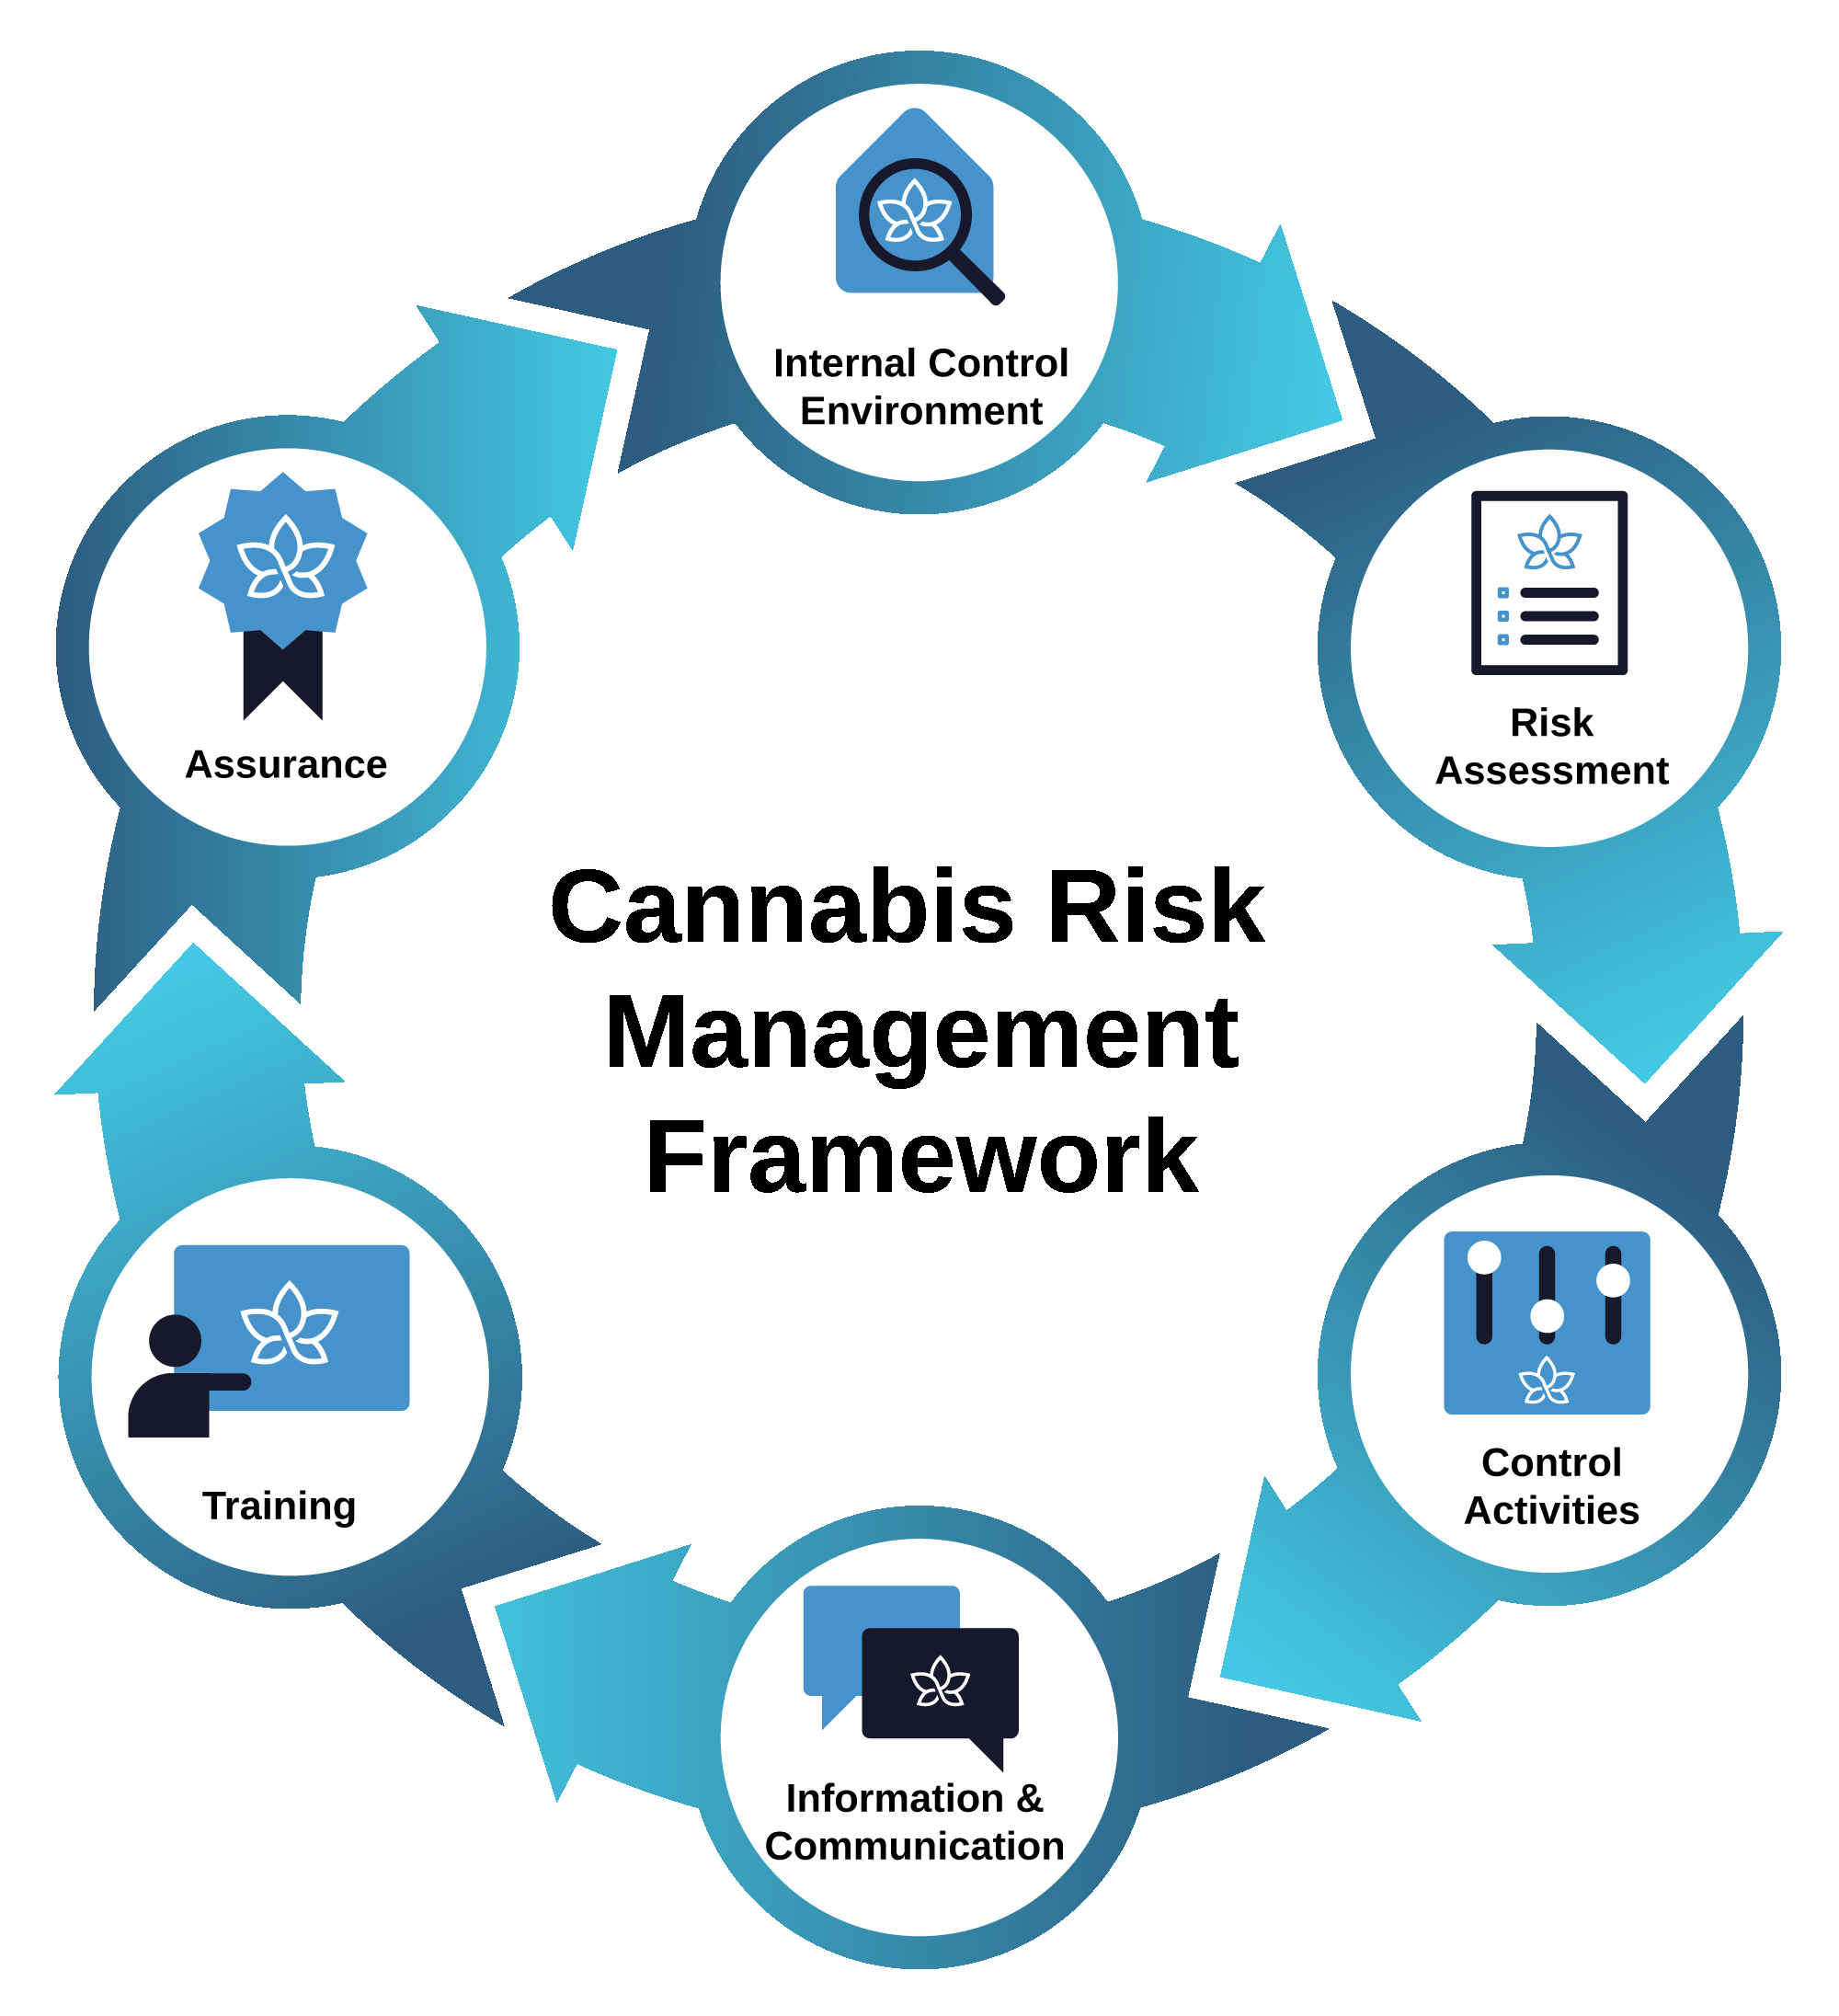

Know what month 3 Studying entails
Study hints for the CRMF
- The CRMF generally includes external stakeholders for our risk management activities; the framework tries to leverage third parties to help with risk management.
- ACCCE acknowledges that some CCBs might not have the risk management skill to implement and mature the entire risk program at once. ACCCE believes you can start with any of the components and mature the risk program over time.
- The CRMF generally suggests that risk management control activities/training/information and communication should be tailored to the job position and risks they face instead of trying to make each position understand risk management in its entirety.
- ACCCE sees risk management as giving a business the opportunity to reduce risk-taking exposure and increase the reward for taking risks. Avoidance, transfer, remediation, and elimination are ways to reduce risk-taking. When you read the test questions, determine if we are asking you about how to reduce a risk or what the benefit would be regardless of how you reduced the risk.

Week 8-10: Risk Assessment
This is a difficult section with many concepts and definitions that need to be understood.
We suggest watching the exam prep video created for this section before starting to study. It will provide insight on where to focus your attention.
Study Hint
Most of the exam questions (31 questions) will be focused on the Risk Assessment.
Have the Risk Assessment section objectives available as you start to study.
- Describe the five major commercial cannabis risk areas
- Discuss the drivers and issues that impact each cannabis risk area
- Describe the risk assessment process
- Apply risk assessment concepts to the commercial cannabis industry
- Define vernacular related to the commercial cannabis risk assessment
Once you have completed the section, review the objectives and conclusion to test your knowledge.
When you have finished reviewing the Risk Assessment section in the handbook and the associated video, check out the Community Discussions on the risk assessment. During these live discussions, we will identify risk scenarios to talk through and provide opportunities for attendees to ask questions. Dates of the next Community Discussion can be found in the events section of the ACCCE website.
Understand
The Risk Assessment process
Study hints for Risk Assessment
- The main difference between money laundering and Illicit cannabis market is that money laundering deals specifically with cash and cash equivalents that are gained through illegal activity where the beneficial owner is trying to be obscured. Conversely, if the situation does not involve cash or cash equivalents but is about illegal activity, ACCCE likely considers it Illicit cannabis market.
- ACCCE only uses inversion and diversion with the Illicit cannabis market risk area.

Week 11-12: Re-review the Commercial Cannabis Handbook
The last 5 hours of study time should be dedicated to re-reading each section to tie major processes and principles together.
We suggest breaking your time up as follows:
- About ACCCE: 45 minutes
- Breakdown of Commercial Cannabis Industry: 1 hour
- Cannabis Risk Management Framework: 1.5 hours
Study Tool
Review the CCCE Exam checklist and take the Pre-Test to gauge if you are ready to take the exam.
- Risk Assessment: 1.75 hours
Use the flashcards you have created for each section to test your knowledge.
ACCCE has created a checklist for each Handbook section of elements you may want to review before taking the exam: CCCE exam readiness checklist.

ACCCE would like to wish all our members studying for the CCCE exam the greatest success. Please reach out to the Membership team at membership@accce.org should you have any concerns.

