

Doing your best on the CCCP exam

Contents
Best Practices 3
Where is the best place to study? 3
When is the best time to study? 3
How long to study? 3
Have all your materials on hand when studying 4
Study smarter, not harder 4
Understand the CCCP Suite of Assessment 5
Know the exam breakdown 5
Know the types of exam questions 5
Memory 6
Memory-Plus 6
Definition 6
Know how to answer multiple-choice questions 7
General multiple-choice guidance 7
Getting familiar with the CCCP exam 8
Know the study breakdown 8
Know what studying entails 9
Week 1: Read entire Commercial Cannabis Handbook 9
Week 2: About ACCCE & Breakdown of Commercial Cannabis Industry 9
Week 3: Cannabis Risk Management Framework (CRMF) 10
Week 4: Risk Assessment 12

While you can try to grasp large quantities of information for the exam, if you are not prepared mentally and physically, your chances of success drop drastically. Studying for an exam is no easy feat. Often just thinking about it causes stress and anxiety.
ACCCE is committed to the success of every member, so before beginning to study for the exam we have laid out how to best use your time by learning the essential objectives and knowledge covered on the test, getting familiar with the test itself, practicing smart techniques, and having a good strategy leading up to the exam.

Best Practices
Best practices are important to incorporate into your studying habits because they provide you with effective guidelines on where, when, and how to study.

Where is the best place to study?
When studying you should have as few distractions as possible. Find a quiet area where you can focus your attention on the material at hand.

When is the best time to study?
Study early in the day if you can. Studies have shown that your mental capacity to retain information decreases the longer you have been awake.

How long to study?
The more you spread out your study time, the more likely you are to remember information later, compared to cramming all your study time into a few sessions. It is best to learn in bite size pieces. Pace yourself and have a schedule.
Each person is unique and learns and absorbs information at different rates; the time and duration of study may need to be extended or decreased based on individual learning abilities.
Remember
Spread out your study time.
Pace yourself and have a schedule.

Have all your materials on hand when studying
The Commercial Cannabis Handbook is only available online so when you begin to study, make sure you have adequate internet connection.
Remember
You have two chances to take the exam.
Flashcards are great learning tools and will help your brain remember concepts and definitions from the handbook.
It is good to have a notebook and pen handy for any notes you may want to take.

Study smarter, not harder
- All the answers in the exam can be found in the Commercial Cannabis Handbook.
- ACCCE has developed exam prep videos where we provide members access to overviews of the Breakdown of Commercial Cannabis Industry.
- ACCCE has created complementary live Community Discussions where ACCCE staff will answer the section specific questions as well as review any examples you would like more clarification on. These thirty-minute discussions are geared towards providing you with a better understanding of major concepts discussed in the Commercial Cannabis Handbook. Keep your eye out for these sessions. You can find the dates of the next Community Discussion in the events section of our website.
- Know and understand the objectives of each section. People often skim over the objectives of a section, but they are very important because they indicate what you will be tested on. The objectives are found in this study guide.
- The first time a concept is discussed in the handbook, it is defined. Defined terms are highlighted in blue. These are important industry terms, concepts, and definitions that you should pay attention to as a large portion of the exam is focused on this.
- Infographics emphasize important information; these pieces of information are generally tested.

Understand the CCCP Suite of Assessment
Knowing how the CCCP exam is broken down and the types of questions that will be asked will provide you with an added advantage. You can tailor your studying needs based on the information provided below.

Know the exam breakdown
The CCCP exam consists of 80 questions and is broken down as follows:
Section | # of questions
About ACCCE | 4
Breakdown of Commercial Cannabis Industry | 20
Cannabis Risk Management Framework | 27
Risk Assessment | 29

Know the types of exam questions
This is a multiple-choice exam where you will be asked to select the correct answer(s) from choices that are offered as a list.
There are three types of questions we will ask on the exam:
- Memory
- Memory-plus
- Definition matching
Study Hint
Most of the exam questions are focused on the last 3 sections (Breakdown of Commercial Cannabis Industry, the CRMF and Risk Assessment). This will help guide you how best to allocate your study time.
Examples of each type are displayed below.

Memory
Which of the following is NOT one of the five main ACCCE risk areas?
Study Hint
The majority of the exam questions are centred around memory type questions.
- Money laundering risk
- Illicit cannabis market risk
- Reputational risk
- Supply chain risk

Memory-Plus
Which one of the following is the best example of inversion within a commercial cannabis industry?
- Extractors allowing after-hours use of equipment to unlicensed individuals
- When an illegal retailer sells marijuana to the public pretending to be a legal retailer
- Growers abusing their license to produce cannabis bound for the black market

Definition
What is residual risk?
- The level of risk that the commercial cannabis business is exposed to without the implementation of controls.
- Strategic risk poses a threat to disrupt a strategy implemented by an organization.
- The risk remaining after controls have been applied to an inherent risk.
- The exposure to legal penalties, financial forfeiture, and material loss an organization faces if it chooses the wrong business decision(s).

Know how to answer multiple-choice questions

General multiple-choice guidance
- Read the question carefully before choosing a response. A specific word or phrase can change the meaning of a statement.
- Be aware of words like “always,” “never,” “only,” “must,” and “completely.” These are usually the wrong answers since there are many exceptions to rules. These are extreme words that are more than likely to be the wrong choice.
- Select all that apply may only be one correct answer. All does not necessarily mean there is more than one correct answer.
- If you must guess, keep in mind that sometimes lengthy or highly specific answers will be the correct answer.

Getting familiar with the CCCP exam
Prioritizing and managing the time you have available to study will help you achieve your goals of passing the CCCP exam. Effective time management will keep you on track and decrease the possibility of taking on more than you can handle.

Know the study breakdown
We have estimated it will take approximately 10-20 hours over a 4-week period to study. This breaks down into approximately 2.5-5 hours of study time per week.
This is how we have broken down the 10-20 hours:
Read entire Commercial Cannabis Handbook | 2 – 4 hours
About ACCCE | 0.5 - 1 hour
Breakdown of Commercial Cannabis Industry | 2 - 4 hours
Cannabis Risk Management Framework | 2.75 – 5.5 hours
Risk Assessment | 2.75 – 5.5 hours
We have created a sample calendar to help you organize study time for the CCCE exam. This is based on an individual who will schedule 20 hours of study time and who will spread out his/her time relatively equally across the three main sections on the exam.
- Study Calendar
Study Tool
Use the study calendar to help structure your study time in an efficient and effective way.
Pace yourself according to your individual learning abilities and modify the calendar as needed.

Know what studying entails

Week 1: Read entire Commercial Cannabis Handbook
When beginning to study for the CCCP exam, read through the Commercial Cannabis Handbook to become familiar with the material and how the sections are set up.
We suggest setting aside 4 hours to do a careful read through.
Study Tool Tip
Creating flashcards after you have reviewed each section will help you memorize key definitions and concepts.
Sample of how to break up your study time for week 1:
- About ACCCE: 30 minutes
- Breakdown of Commercial Cannabis Industry: 1 hour
- Cannabis Risk Management Framework: 1.25 hour
- Risk Assessment: 1.25 hour

Week 2: About ACCCE & Breakdown of Commercial Cannabis Industry

About ACCCE
Have the About ACCCE section objectives available as you start to study.
Study Tool
Don’t forget to incorporate exam prep section videos into your study time.
- Describe ACCCE’s role and importance
- State the Mission of ACCCE
- Differentiate between the ACCCE designations
Once you have completed the section, review the objectives and section conclusion to test your knowledge.

Breakdown of Commercial Cannabis Industry (BCCI)
We suggest watching the exam prep video created for this section before starting to study. It will provide insight on where to focus your attention.
Have the Breakdown of Commercial Cannabis Industry section objectives available as you start to study.
- Understand the key sectors of the commercial cannabis industry
- Understand the standard vernacular for the commercial cannabis sectors
- Understand the flow of the supply chain for the commercial cannabis industry
Once you have completed the section, review the objectives and section conclusion to test your knowledge.
Study hints for Breakdown of Commercial Cannabis Industry
- The commercial cannabis industry can be broken down by sectors to identify how the cannabis product is progressing through the supply chain and the key activities that are being performed within that sector.
This provides a foundation of the inherent risks that commercial cannabis businesses within these subsectors face.
- Testing occurs at many stages because there are many potential sources of contamination from growing
to when it reaches the end customer.
- Finished goods does not imply they are ready for sale to a consumer, but rather a state of the cannabis product. Generally, packaging must take place for a finished good to be sold to a consumer.

When you have finished reviewing the Breakdown of Commercial Cannabis Industry section in the handbook and have watched the exam prep videos, check out the Community Discussions on the Breakdown of Commercial Cannabis Industry. During these live discussions, we will identify risk scenarios to talk through and provide opportunities for attendees to ask questions. Dates of the next Community Discussion can be found in the events section of the ACCCE website.

Week 3: Cannabis Risk Management Framework (CRMF)
Have the CRMF section objectives available as you start to study.
Study Tool
Once you have read a section in its entirety, start creating flashcards of major concepts and definitions.
- Describe the major components of the CRMF
- Define vernacular involved in implementing the CRMF
- Explain why using the CRMF is an important part of developing control activities
Once you have completed the section, review the objectives and conclusion to test your knowledge.
Know: The six components of the CRMF
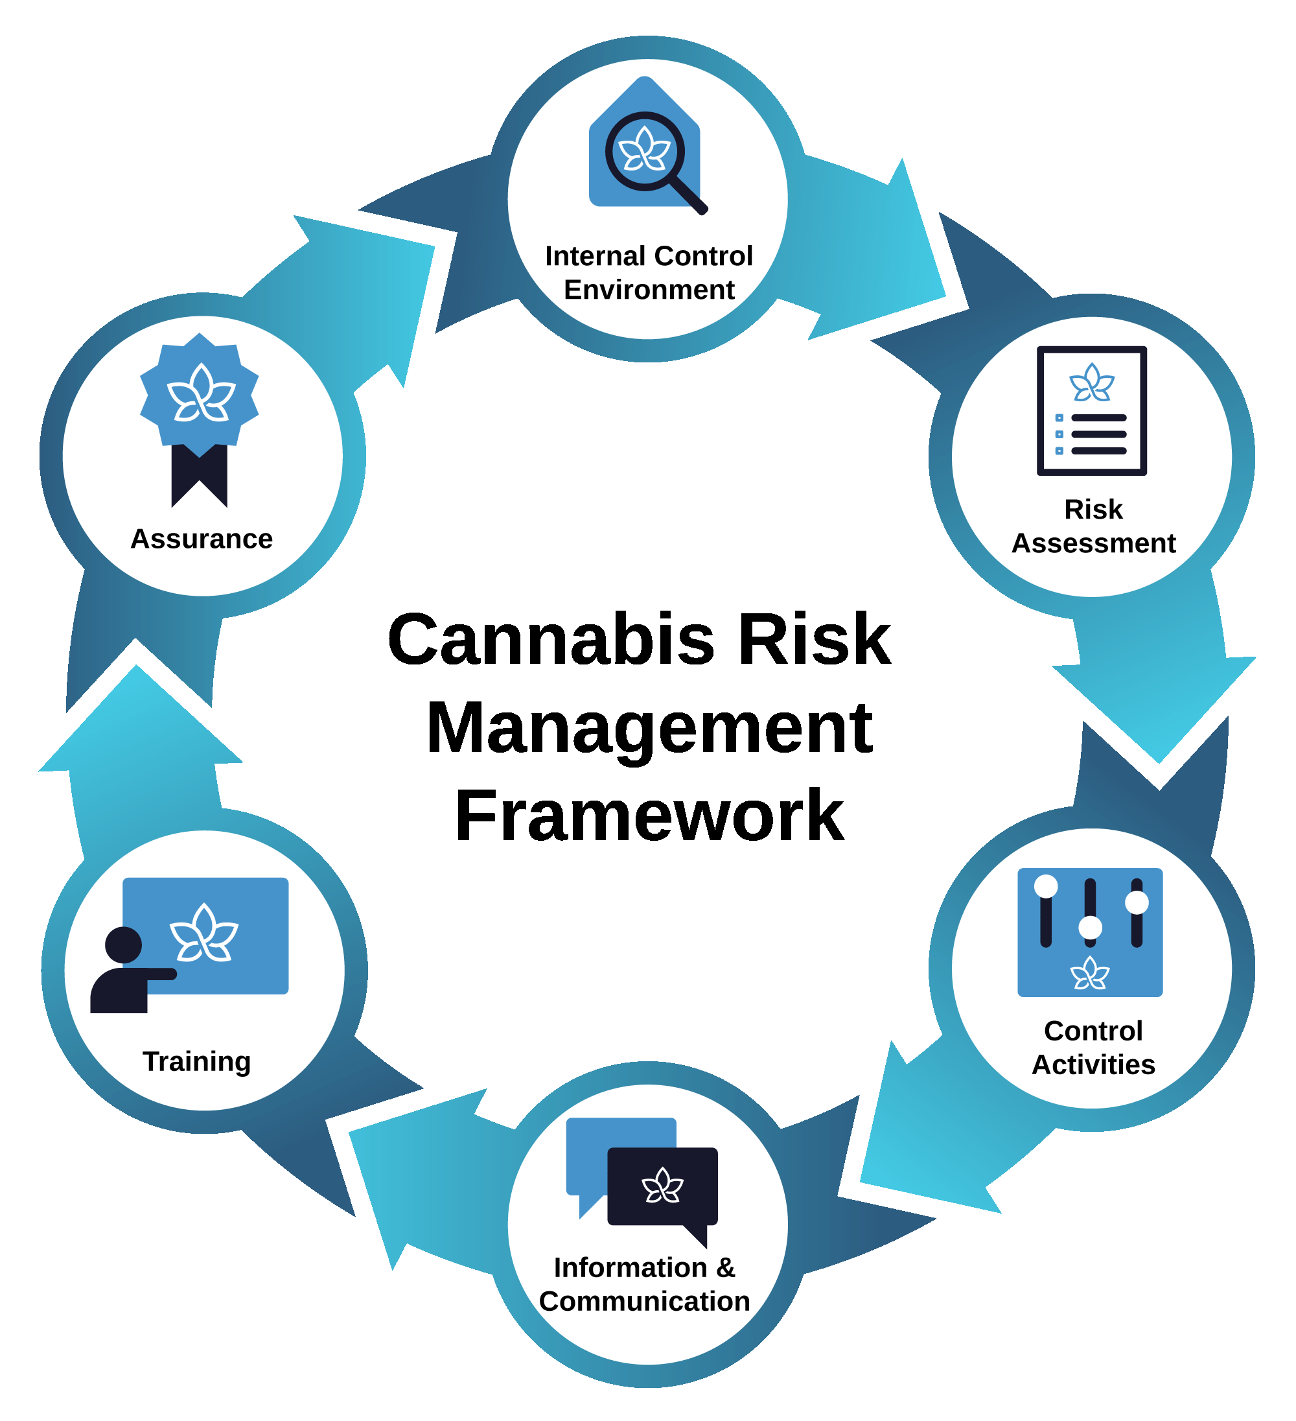
Study hints for the CRMF
- The CRMF generally includes external stakeholders for our risk management activities; the framework tries to leverage third parties to help with risk management.
- ACCCE acknowledges that some CCBs might not have the risk management skill to implement and mature the entire risk program at once. ACCCE believes you can start with any of the components and mature the risk program over time.
- The CRMF generally suggests that risk management control activities/training/information and communication should be tailored to the job position and risks they face instead of trying to make each position understand risk management in its entirety.
- ACCCE sees risk management as giving a business the opportunity to reduce risk-taking exposure and increase the reward for taking risks. Avoidance, transfer, remediation, and elimination are ways to reduce risk-taking. When you read the test questions, determine if we are asking you about how to reduce a risk or what the benefit would be regardless of how you reduced the risk.
When you have finished reviewing the Cannabis Risk Management Framework section in the handbook, check out our Community Discussions on the Cannabis Risk Management Framework. During these live discussions, we will identify risk scenarios to talk through and provide opportunities for attendees to ask questions. Dates of the next Community Discussion can be found in the events section of the ACCCE website.

Week 4: Risk Assessment
This is a difficult section with many concepts and definitions that need to be understood.
Have the Risk Assessment section objectives available as you start to study.
Study Hint
Most of the exam questions (56 questions) will be focused on the CRMF and Risk Assessment.
- Describe the five major commercial cannabis risk areas
- Identify the drivers and issues that impact each cannabis risk area
- Define a risk profile
- Define vernacular related to the commercial cannabis risk assessment
Once you have completed the section, review the objectives and conclusion to test your knowledge.

When you have finished reviewing the Risk Assessment section in the handbook, check out the Community Discussions on the risk assessment. During these live discussions, we will identify risk scenarios to talk through and provide opportunities for attendees to ask questions. Dates of the next Community Discussion can be found in the events section of the ACCCE website.
Understand
The Risk Assessment process
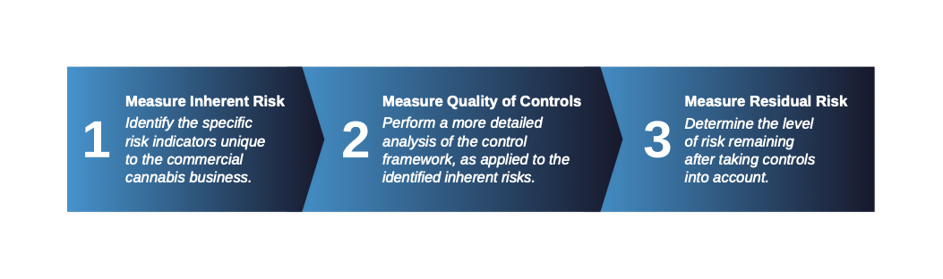
Study hints for Risk Assessment
- The main difference between money laundering and illicit cannabis market is that money laundering deals specifically with cash and cash equivalents that are gained through illegal activity where the beneficial owner is trying to be obscured. Conversely, if the situation doesn’t involve cash or cash equivalents but is about illegal activity, ACCCE likely considers it to be the illicit cannabis market.
- ACCCE only uses inversion and diversion with the illicit cannabis market risk area.

ACCCE has created a checklist for each Handbook section of elements you may want to review before taking the exam: CCCP exam readiness checklist.
Study Tool
Review the CCCP Exam checklist to gauge if you are ready to take the exam.

ACCCE would like to wish all our members studying for the CCCP exam the greatest success. Please reach out to the Membership team at membership@accce.org should you have any concerns.

